Maven Web Application

We can create a simple maven web application example by executing the **archetype:generate** command of **mvn tool**.

To create a simple java project using maven, you need to open command prompt and run the **archetype:generate** command of mvn tool.

Syntax

The **syntax** to generate the project architecture is given below:

1. mvn archetype:generate -DgroupId=groupid -DartifactId=artifactid
2. -DarchetypeArtifactId=maven-archetype-webapp -DinteractiveMode=booleanValue

Example

The **example** to generate the project architecture is given below:

1. mvn archetype:generate -DgroupId=com.javatpoint -DartifactId=CubeGeneratorWeb
2. -DarchetypeArtifactId=maven-archetype-webapp -DinteractiveMode=false

Note: Here, we are using maven-archetype-webapp to create simple maven web application. if you use maven-archetype-quickstart, it will generate a simple maven core project.

Output

Now it will **generate following code in the command prompt**:

1. mvn archetype:generate -DgroupId=com.javatpoint -DartifactId=CubeGeneratorWe
2. b -DarchetypeArtifactId=maven-archetype-webapp -DinteractiveMode=false
3. [INFO] Scanning for projects...
4. [INFO]
5. [INFO] ------------------------------------------------------------------------
6. [INFO] Building Maven Stub Project (No POM) 1
7. [INFO] ------------------------------------------------------------------------
8. [INFO]
9. [INFO] **>>>** maven-archetype-plugin:2.2:generate (default-cli) @ standalone-pom **>>**
10. **>**
11. [INFO]
12. [INFO] **<<<** **maven-archetype-plugin:2.2:generate** (default-cli) @ standalone-pom **<<**
13. **<**
14. [INFO]
15. [INFO] --- maven-archetype-plugin:2.2:generate (default-cli) @ standalone-pom --
16. -
17. [INFO] Generating project in Batch mode
18. Downloading: http://repo.maven.apache.org/maven2/org/apache/maven/archetypes/mav
19. en-archetype-webapp/1.0/maven-archetype-webapp-1.0.jar
20. Downloaded: http://repo.maven.apache.org/maven2/org/apache/maven/archetypes/mave
21. n-archetype-webapp/1.0/maven-archetype-webapp-1.0.jar (4 KB at 3.8 KB/sec)
22. Downloading: http://repo.maven.apache.org/maven2/org/apache/maven/archetypes/mav
23. en-archetype-webapp/1.0/maven-archetype-webapp-1.0.pom
24. Downloaded: http://repo.maven.apache.org/maven2/org/apache/maven/archetypes/mave
25. n-archetype-webapp/1.0/maven-archetype-webapp-1.0.pom (533 B at 0.8 KB/sec)
26. [INFO] -------------------------------------------------------------------------
27. ---
28. [INFO] Using following parameters for creating project from Old (1.x) Archetype:
29. maven-archetype-webapp:1.0
30. [INFO] -------------------------------------------------------------------------
31. ---
32. [INFO] Parameter: groupId, Value: com.javatpoint
33. [INFO] Parameter: packageName, Value: com.javatpoint
34. [INFO] Parameter: package, Value: com.javatpoint
35. [INFO] Parameter: artifactId, Value: CubeGeneratorWeb
36. [INFO] Parameter: basedir, Value: D:\
37. [INFO] Parameter: version, Value: 1.0-SNAPSHOT
38. [INFO] project created from Old (1.x) Archetype in dir: D:\CubeGeneratorWeb
39. [INFO] ------------------------------------------------------------------------
40. [INFO] BUILD SUCCESS
41. [INFO] ------------------------------------------------------------------------
42. [INFO] Total time: 10.273s
43. [INFO] Finished at: Thu Dec 26 19:25:04 IST 2013
44. [INFO] Final Memory: 10M/24M
45. [INFO] ------------------------------------------------------------------------
46. 'cmd' is not recognized as an internal or external command,
47. operable program or batch file.

Generated Directory Structure

Now go to the current directory from where you have executed the mvn command. For example: **d:\CubeGeneratorWeb**. You will see that a simple java project is created that has the following directory:

1. CubeGenerator
2. -src
3. --main
4. ---resources
5. ---webapp
6. ----WEB-INF
7. -----web.xml
8. ----index.jsp
9. -pom.xml

As you can see, there are created 3 files pom.xml, index.jsp and web.xml. Let's have a quick look at these files:

#### 1) Automatically Generated pom.xml file

1. **<project** xmlns="http://maven.apache.org/POM/4.0.0"
2. xmlns:xsi="http://www.w3.org/2001/XMLSchema-instance"
3. xsi:schemaLocation="http://maven.apache.org/POM/4.0.0
4. http://maven.apache.org/maven-v4_0_0.xsd"**>**
5. **<modelVersion>**4.0.0**</modelVersion>**
6. **<groupId>**com.javatpoint**</groupId>**
7. **<artifactId>**CubeGeneratorWeb**</artifactId>**
8. **<packaging>**war**</packaging>**
9. **<version>**1.0-SNAPSHOT**</version>**
10. **<name>**CubeGeneratorWeb Maven Webapp**</name>**
11. **<url>**http://maven.apache.org**</url>**
12. **<dependencies>**
13. **<dependency>**
14. **<groupId>**junit**</groupId>**
15. **<artifactId>**junit**</artifactId>**
16. **<version>**3.8.1**</version>**
17. **<scope>**test**</scope>**
18. **</dependency>**
19. **</dependencies>**
20. **<build>**
21. **<finalName>**CubeGeneratorWeb**</finalName>**
22. **</build>**
23. **</project>**

#### 2) Automatically Generated index.jsp file

1. **<html>**
2. **<body>**
3. **<h2>**Hello World!**</h2>**
4. **</body>**
5. **</html>**

#### 3) Automatically Generated web.xml file

1. <!DOCTYPE web-app PUBLIC
2. "-//Sun Microsystems, Inc.//DTD Web Application 2.3//EN"
3. "http://java.sun.com/dtd/web-app_2_3.dtd" **>**
5. **<web-app>**
6. **<display-name>**Archetype Created Web Application**</display-name>**
7. **</web-app>**

## Deploy and Run the Maven Web Project

Now you need to deploy the project on the server and access it by the following url:

http://<host-name>:<portnumber>/projectname, for example: http://localhost:8888/CubeGeneratorWeb

## maven webapp outputMaven Webapp in Eclipse

You can import the maven web project in eclipse. To do so, perform following steps:

**1) Open eclipse IDE**

**2) Import the maven project**

File Menu -> Import -> Maven -> Existing Maven Projects

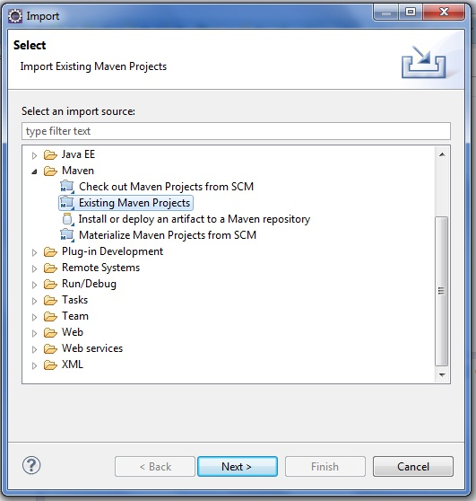

-> Next -> Browse Project

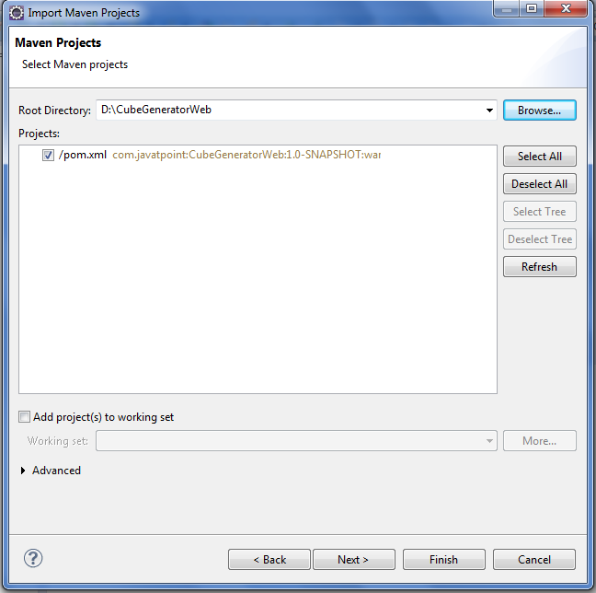

[**next →**](https://www.javatpoint.com/maven-plugin)[**←prev**](https://www.javatpoint.com/maven-example)

# Maven Web Application

We can create a simple maven web application example by executing the **archetype:generate** command of **mvn tool**.

To create a simple java project using maven, you need to open command prompt and run the **archetype:generate** command of mvn tool.

#### Syntax

The **syntax** to generate the project architecture is given below:

1. mvn archetype:generate -DgroupId=groupid -DartifactId=artifactid
2. -DarchetypeArtifactId=maven-archetype-webapp -DinteractiveMode=booleanValue

#### Example

The **example** to generate the project architecture is given below:

1. mvn archetype:generate -DgroupId=com.javatpoint -DartifactId=CubeGeneratorWeb
2. -DarchetypeArtifactId=maven-archetype-webapp -DinteractiveMode=false

#### Note: Here, we are using maven-archetype-webapp to create simple maven web application. if you use maven-archetype-quickstart, it will generate a simple maven core project.

#### Output

Now it will **generate following code in the command prompt**:

1. mvn archetype:generate -DgroupId=com.javatpoint -DartifactId=CubeGeneratorWe
2. b -DarchetypeArtifactId=maven-archetype-webapp -DinteractiveMode=false
3. [INFO] Scanning for projects...
4. [INFO]
5. [INFO] ------------------------------------------------------------------------
6. [INFO] Building Maven Stub Project (No POM) 1
7. [INFO] ------------------------------------------------------------------------
8. [INFO]
9. [INFO] **>>>** maven-archetype-plugin:2.2:generate (default-cli) @ standalone-pom **>>**
10. **>**
11. [INFO]
12. [INFO] **<<<** **maven-archetype-plugin:2.2:generate** (default-cli) @ standalone-pom **<<**
13. **<**
14. [INFO]
15. [INFO] --- maven-archetype-plugin:2.2:generate (default-cli) @ standalone-pom --
16. -
17. [INFO] Generating project in Batch mode
18. Downloading: http://repo.maven.apache.org/maven2/org/apache/maven/archetypes/mav
19. en-archetype-webapp/1.0/maven-archetype-webapp-1.0.jar
20. Downloaded: http://repo.maven.apache.org/maven2/org/apache/maven/archetypes/mave
21. n-archetype-webapp/1.0/maven-archetype-webapp-1.0.jar (4 KB at 3.8 KB/sec)
22. Downloading: http://repo.maven.apache.org/maven2/org/apache/maven/archetypes/mav
23. en-archetype-webapp/1.0/maven-archetype-webapp-1.0.pom
24. Downloaded: http://repo.maven.apache.org/maven2/org/apache/maven/archetypes/mave
25. n-archetype-webapp/1.0/maven-archetype-webapp-1.0.pom (533 B at 0.8 KB/sec)
26. [INFO] -------------------------------------------------------------------------
27. ---
28. [INFO] Using following parameters for creating project from Old (1.x) Archetype:
29. maven-archetype-webapp:1.0
30. [INFO] -------------------------------------------------------------------------
31. ---
32. [INFO] Parameter: groupId, Value: com.javatpoint
33. [INFO] Parameter: packageName, Value: com.javatpoint
34. [INFO] Parameter: package, Value: com.javatpoint
35. [INFO] Parameter: artifactId, Value: CubeGeneratorWeb
36. [INFO] Parameter: basedir, Value: D:\
37. [INFO] Parameter: version, Value: 1.0-SNAPSHOT
38. [INFO] project created from Old (1.x) Archetype in dir: D:\CubeGeneratorWeb
39. [INFO] ------------------------------------------------------------------------
40. [INFO] BUILD SUCCESS
41. [INFO] ------------------------------------------------------------------------
42. [INFO] Total time: 10.273s
43. [INFO] Finished at: Thu Dec 26 19:25:04 IST 2013
44. [INFO] Final Memory: 10M/24M
45. [INFO] ------------------------------------------------------------------------
46. 'cmd' is not recognized as an internal or external command,
47. operable program or batch file.

#### Generated Directory Structure

Now go to the current directory from where you have executed the mvn command. For example: **d:\CubeGeneratorWeb**. You will see that a simple java project is created that has the following directory:

1. CubeGenerator
2. -src
3. --main
4. ---resources
5. ---webapp
6. ----WEB-INF
7. -----web.xml
8. ----index.jsp
9. -pom.xml

As you can see, there are created 3 files pom.xml, index.jsp and web.xml. Let's have a quick look at these files:

#### 1) Automatically Generated pom.xml file

1. **<project** xmlns="http://maven.apache.org/POM/4.0.0"
2. xmlns:xsi="http://www.w3.org/2001/XMLSchema-instance"
3. xsi:schemaLocation="http://maven.apache.org/POM/4.0.0
4. http://maven.apache.org/maven-v4_0_0.xsd"**>**
5. **<modelVersion>**4.0.0**</modelVersion>**
6. **<groupId>**com.javatpoint**</groupId>**
7. **<artifactId>**CubeGeneratorWeb**</artifactId>**
8. **<packaging>**war**</packaging>**
9. **<version>**1.0-SNAPSHOT**</version>**
10. **<name>**CubeGeneratorWeb Maven Webapp**</name>**
11. **<url>**http://maven.apache.org**</url>**
12. **<dependencies>**
13. **<dependency>**
14. **<groupId>**junit**</groupId>**
15. **<artifactId>**junit**</artifactId>**
16. **<version>**3.8.1**</version>**
17. **<scope>**test**</scope>**
18. **</dependency>**
19. **</dependencies>**
20. **<build>**
21. **<finalName>**CubeGeneratorWeb**</finalName>**
22. **</build>**
23. **</project>**

#### 2) Automatically Generated index.jsp file

1. **<html>**
2. **<body>**
3. **<h2>**Hello World!**</h2>**
4. **</body>**
5. **</html>**

#### 3) Automatically Generated web.xml file

1. <!DOCTYPE web-app PUBLIC
2. "-//Sun Microsystems, Inc.//DTD Web Application 2.3//EN"
3. "http://java.sun.com/dtd/web-app_2_3.dtd" **>**
5. **<web-app>**
6. **<display-name>**Archetype Created Web Application**</display-name>**
7. **</web-app>**

## Deploy and Run the Maven Web Project

Now you need to deploy the project on the server and access it by the following url:

http://<host-name>:<portnumber>/projectname, for example: http://localhost:8888/CubeGeneratorWeb

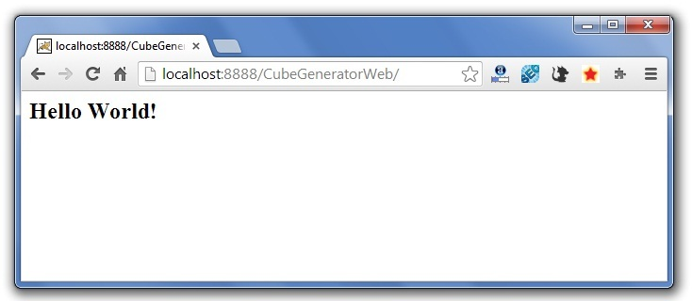

## Maven Webapp in Eclipse

You can import the maven web project in eclipse. To do so, perform following steps:

**1) Open eclipse IDE**

**2) Import the maven project**

File Menu -> Import -> Maven -> Existing Maven Projects



-> Next -> Browse Project



-> Finish.

**3) Run the maven web project**

Right click on project -> Run As -> Run on Server

**Directory Structure of Maven Webapp in Eclipse**